Name of Student: Husam Ali Abdalla Nour | PRN:25070122086
Semester: III | Year : AY 2026-27
Subject: Programming with Java
ASSIGNMENT No : 16
TITLE : User-Defined Exceptions
Problem Statement
Write a Java program to create and handle a user-defined exception.
Learning Objectives
To create and implement custom exceptions for application-specific error handling.

Programme
class InvalidAgeException extends Exception {

InvalidAgeException(String message) {
super(message);
}
}

public class UserHandle {

public static void main(String[] args) {

int age = 16;

try {

if (age < 18) {
throw new InvalidAgeException("Age must be 18 or above");
}

System.out.println("Eligible");

} catch (InvalidAgeException e) {

System.out.println(e.getMessage());
}
}
}

Output
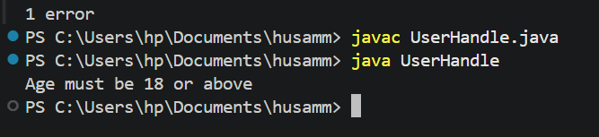
Practice questions
- Create a Voting System that throws a custom exception if age is below 18.
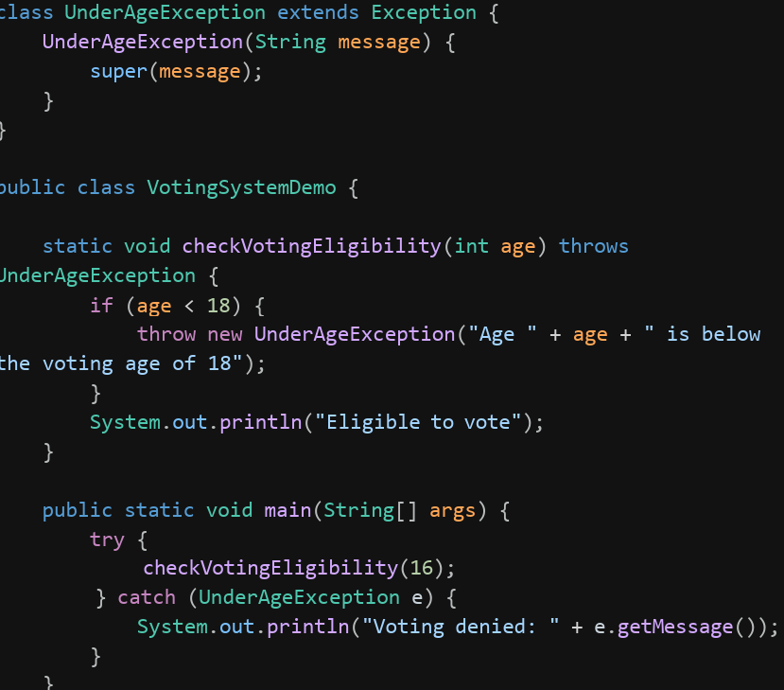
Output
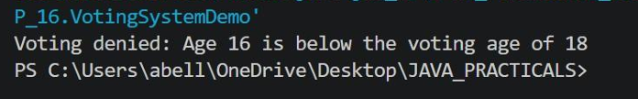
- Create a Driving License System that throws a custom exception if the user’s age is below 18. If the age is valid, display that the user is eligible for a driving license.
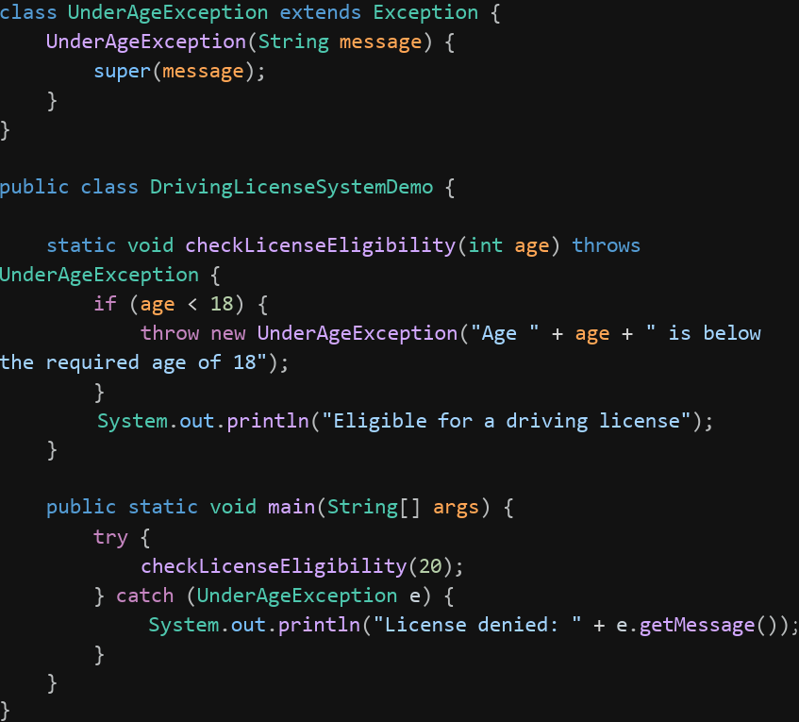
Output
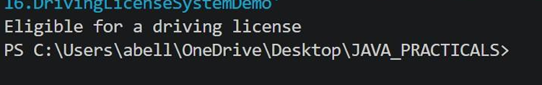
Conclusion
Custom exceptions let a program raise errors that are meaningful to its own business logic, rather than relying only on Java's built-in exception types. By extending Exception and providing a descriptive message, custom exceptions make validation failures like an invalid age for voting or licensing easier to identify, handle, and debug.

